Go and delete migrations folder inside my app

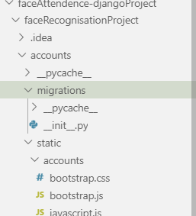

pip install mysqlclient

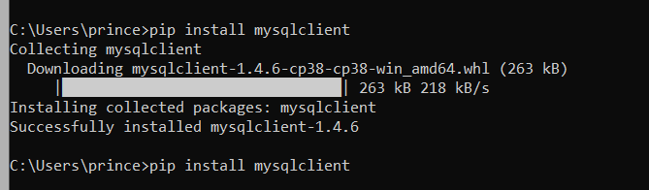

Go to settings and replace database with

Note name is the database name

DATABASES = {
'default': {
'ENGINE': 'django.db.backends.mysql',
'NAME': 'djangoexperiments',
'USER': 'root',
'PASSWORD': '',
'HOST': 'localhost',
'PORT': '3306',

}
}

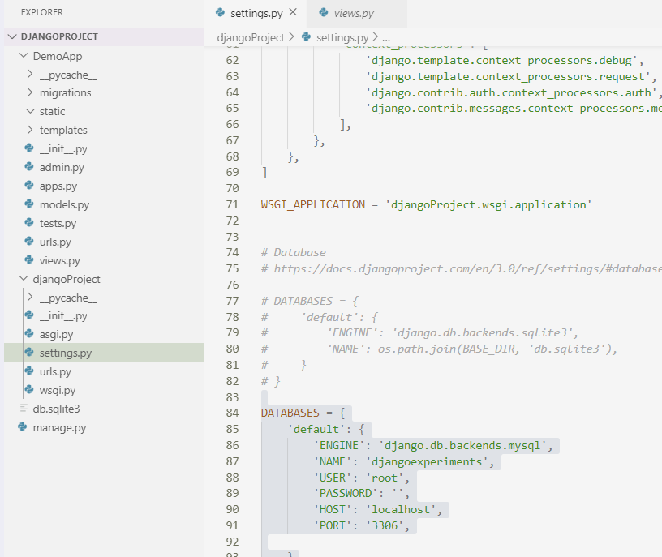

Not working try again

